1

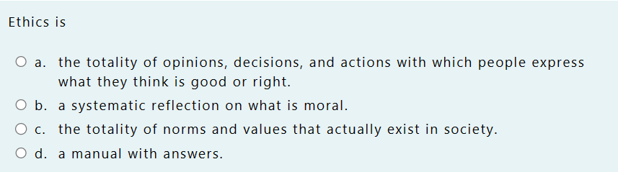

2

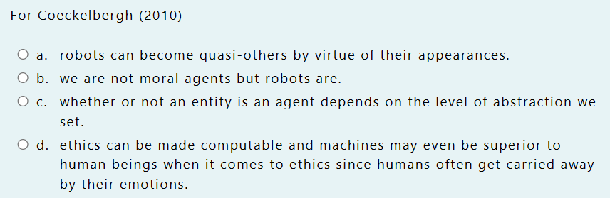

3

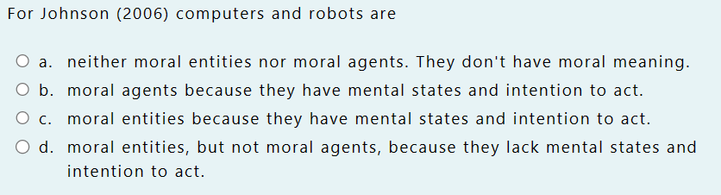

4

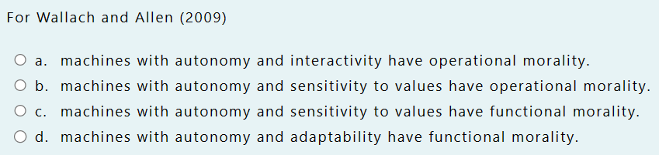

5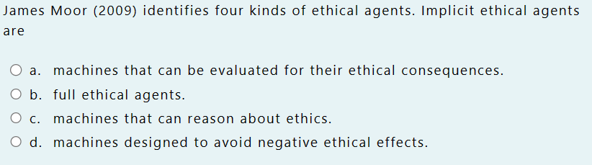

6

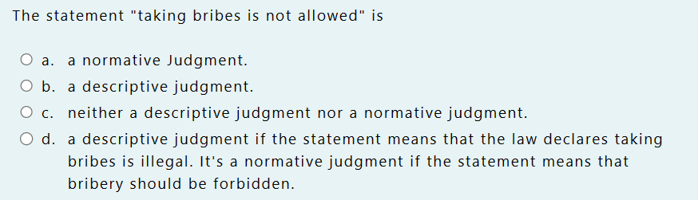

7

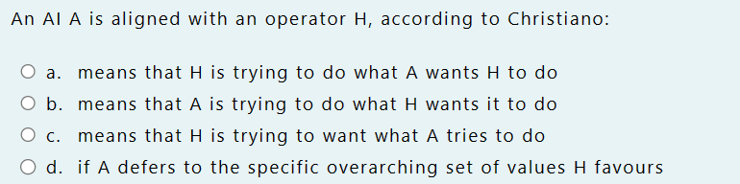

8

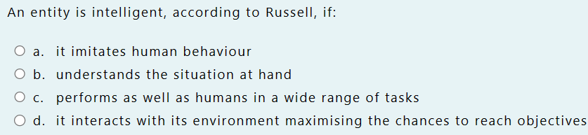

9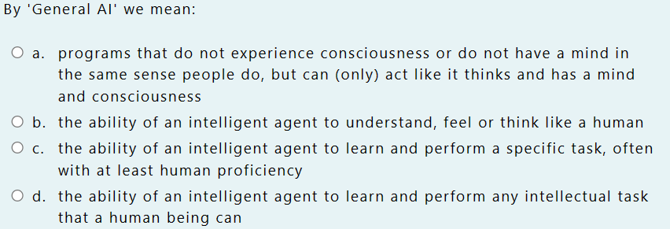

10

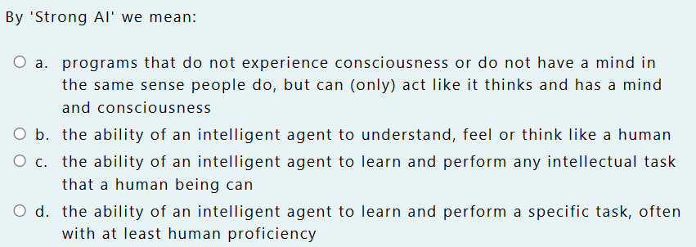

11

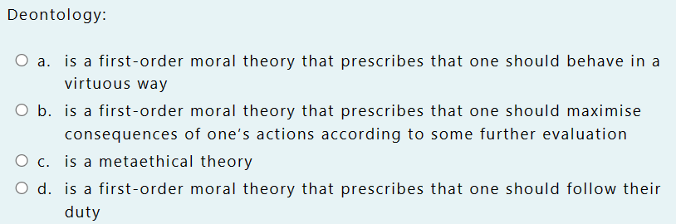

12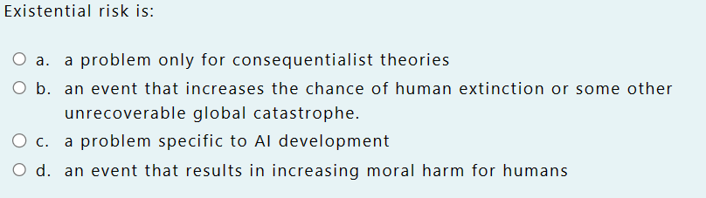

13

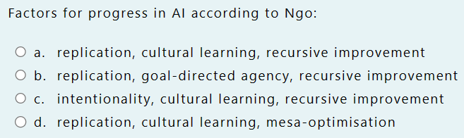

14

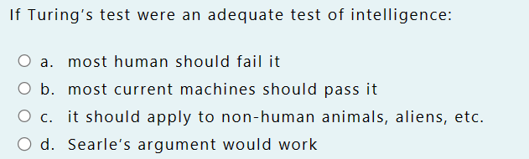

15

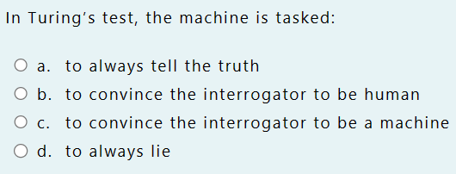

16

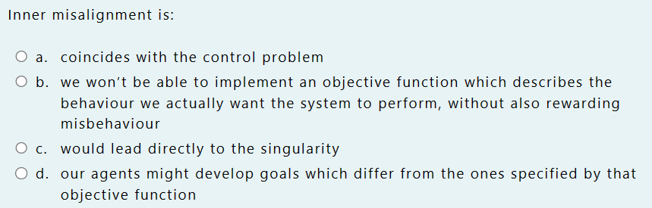

17

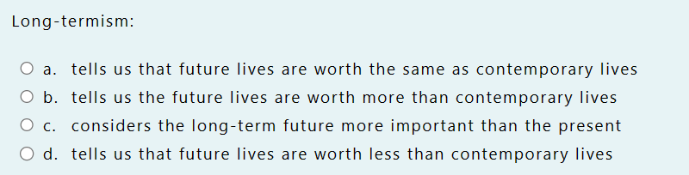

18

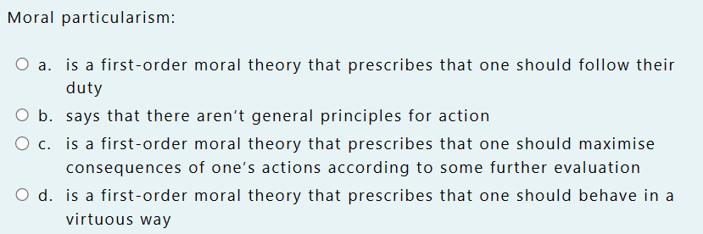

19

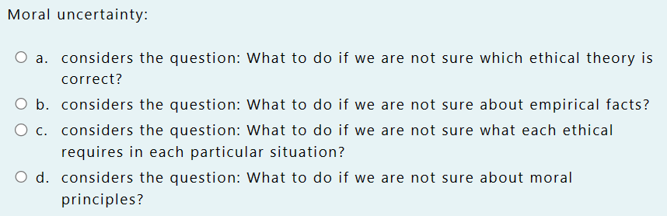

20

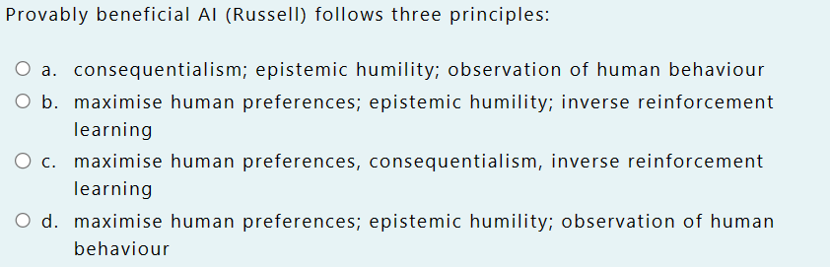

21

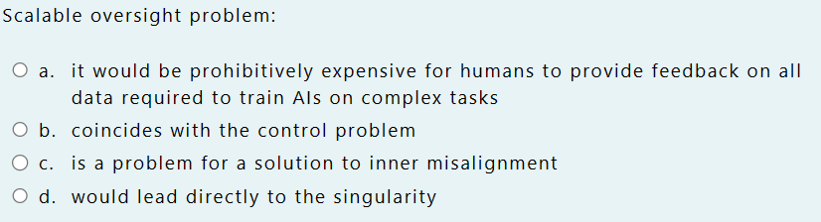

22

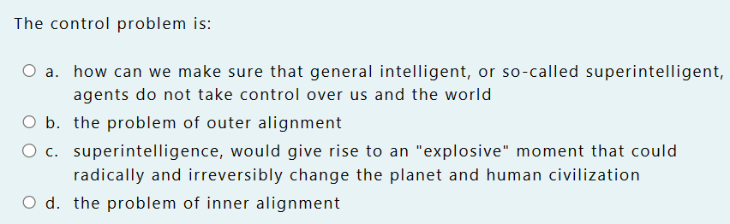

23

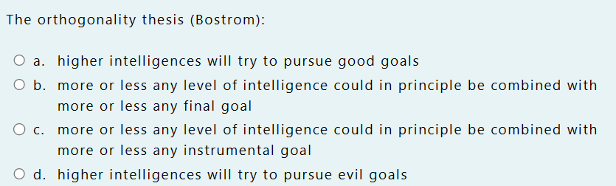

24

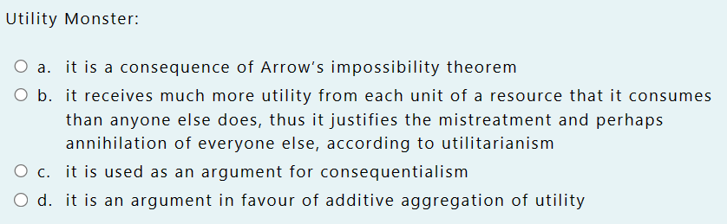

(b-a-d-c-d-d-b-8d-9d-10-b-11d-12b-13a-14c-15b-16d-17d-18b-19a-20c-21a-22a-23b-24b)

8:russell

the other 3 options are other definition we have seen.

C: general intelligence

A: strong Ai

russell interact with environment in such a way to maximise the possibility to reaching the objective (of the AI)

11.

Only one that makes sense, is not a metathical

12. From bostrom definition, event that increase the change of global exstieotion, not limited to humans. Can or can not be a moral harm (depeding of point of view)

13.

See last week paper. Disntnction between replication and recursive improvement

Not the same thing, could be replication without recursive improment

Replication: extremely easy and cost almost nothing to have lots of agents, lead fast progress toward intelligence

Recursive improvement:

14.

Critique, is antrhopocentric theory

15.

16.

B more of less definition of outer misslagiment

17.

Future lives and long term future (ti might not have human lifes)

Long terminism is about human

Future lifes wort more then the present because there would me way many mor epeople alive. Each life is worth the same. Since in the future many more lifes it is more important.

Eahc life is worth the same. Choose the moral life, just add the values.

WHAT DOES JOHNSON DISTINGUISH BETWEEN  
A. Intrinsic value and instrumental value

B. Natural entities and human-made objects

C. Internal state and external state

D. Artifacts and socio-technical artifact

B. Natural entities and human-made objects .

WHICH OF THESE IS NOT A CONDITION FOR MORAL AGENCY

A. The outward behaviour have an outward effect

B. Agent with internal state: consists of desires, beliefs and other intentional state

C. The external state is the cause of the outward event  
D. The effect have to be on a recipient that can be harmed or helped

C. The external state is the cause of the outward event .

WHAT ARE THE CONDITIONS FOR MORAL AGENCY?

A. Agent with internal state, there is an outward embodied event, there is a interaction with a network of others agents, the internal state is the cause of the outward event, the outward behavior have an outward effect, the effect have to be on a recipient that can be harmed or helped

B. Agent with internal state, the internal state is the cause of the outward event, the outward behavior have an outward effect, the effect have to be on a recipient that can be harmed or helped

C. Agent with internal state, there is an outward embodied event, the internal state is the cause of the outward event, the outward behavior have an inward effect, the effect have to be on a recipient that can be harmed or helped

D. Agent with internal state, there is an outward embodied event, the internal state is the cause of the outward event, the outward behavior have an outward effect, the effect have to be on a recipient that can be harmed or helped

D. Agent with internal state, there is an outward embodied event, the internal state is the cause of the outward event, the outward behavior have an outward effect, the effect have to be on a recipient that can be harmed or helped .

WHICH OF THESE CONDITIONS FOR MORAL AGENCY IS NOT SATISFIED BY A COMPUTER?

A. Agent with internal state

B. The internal state is the cause of the outward event

C. The outward behavior have an outward effect

D. There is an outward embodied event

A. Agent with internal state .

WHICH OF THESE STATEMENTS IS CERTAINLY TRUE?

A. Artificial intelligence can replace human intelligence completely

B. AI is not capable of learning and improving on its own

C. A computer system's behaviour depends on human behaviour

D. AI is only used for specific tasks

C. A computer system's behaviour depends on human behaviour .

WHAT IS TRUE ABOUT COMPUTER SYSTEMS?

A. Computers are moral agents and are not-neutral

B. Computers are moral agents and are close to being neutral

C. Computers are close to being moral agents and are not-neutral

D. Computers are close to being moral agents and are neutral

C. Computers are close to being moral agents and are not-neutral .

WHICH OF THESE IS AN ARTEFACT (AND NOT A TECHNOLOGY) FOR JOHNSON

A. A piece of jewelry

B. A software program

C. A smartphone

D. A car

A. A piece of jewelry .

WHICH OF THESE IS A TECHNOLOGY (AND NOT AN ARTEFACT) FOR JOHNSON

A. A sculpture

B. A painting

C. A software program

D. A musical instrument

C. A software program .

WHO SUGGESTED THE FUNCTIONAL MORALITY (HOW CAN WE CREATE AN ARTIFICIAL MORAL AGENT?)

A. Wallach-Allen

B. Jonhson

C. Van de Poel

D. Sullins

A. Wallach-Allen .

WHAT IS TRUE ABOUT FUNCTIONAL MORALITY

WHICH OF THESE IS NOT A REQUIREMENT FOR FULL MORAL AGENCY PROPOSED BY SULLINS?

A. Intentionality

B. Autonomy

C. Adaptability

D. Responsibility

C. Adaptability

WHICH OF THESE IS THE CORRECT DEFINITION OF AUTONOMY FOR SULLINS?

A. Machine not under the direct control of any other programmer or user

B. Actions are deliberately calculated by the machine

C. Robot behaves responsibly to other moral agents

D. The robot evaluates the ethical correctness of actions on the basis on the basis of a characteristic that affects the action in itself

A. Machine not under the direct control of any other programmer or user

WHO DEFINED THE MINDLESS MORALITY?

A. Sullins

B. Wallach-Allen

C. Floridi-Sanders

D. Van de Poel

C. Floridi-Sanders .

WHICH OF THESE IS NOT A COMPONENT OF THE MINDLESS MORALITY OF FLORIDI-SANDERS

A. Responsibility

B. Interactivity

C. Autonomy

D. Capable of moral qualifiable actions

A. Responsibility .

FOR FLORIDI-SANDERS WHAT IS THE DEFINITION OF ADAPTIVITY?

A. Response to the stimulus by changing state

B. Ability to change state with the stimulus

C. Ability to change state without stimulus

D. Ability to change the transition rule

D. Ability to change the transition rule .

WHICH OF THESE IS THE CORRECT DEFINITION OF RESPONSIBILITY FOR SULLINS?

A. Machine not under the direct control of any other programmer or user

B. Actions are deliberately calculated by the machine

C. Robot behaves responsibly to other moral agents

D. The robot evaluates the ethical correctness of actions on the basis on the basis of a characteristic that affects the action in itself

C. Robot behaves responsibly to other moral agents .